Software engineering for big data analaysis

CSA-1035

EXP NO: -5

5. Draw a USE-CASE diagram for an ATM System using CASE tool. The banking system allows a customer to access the financial transactions by ATM System; it has a step by step process describing the work of this process and elaborates what work can be done by customer, banking system, administrator and technicians with the ATM system.

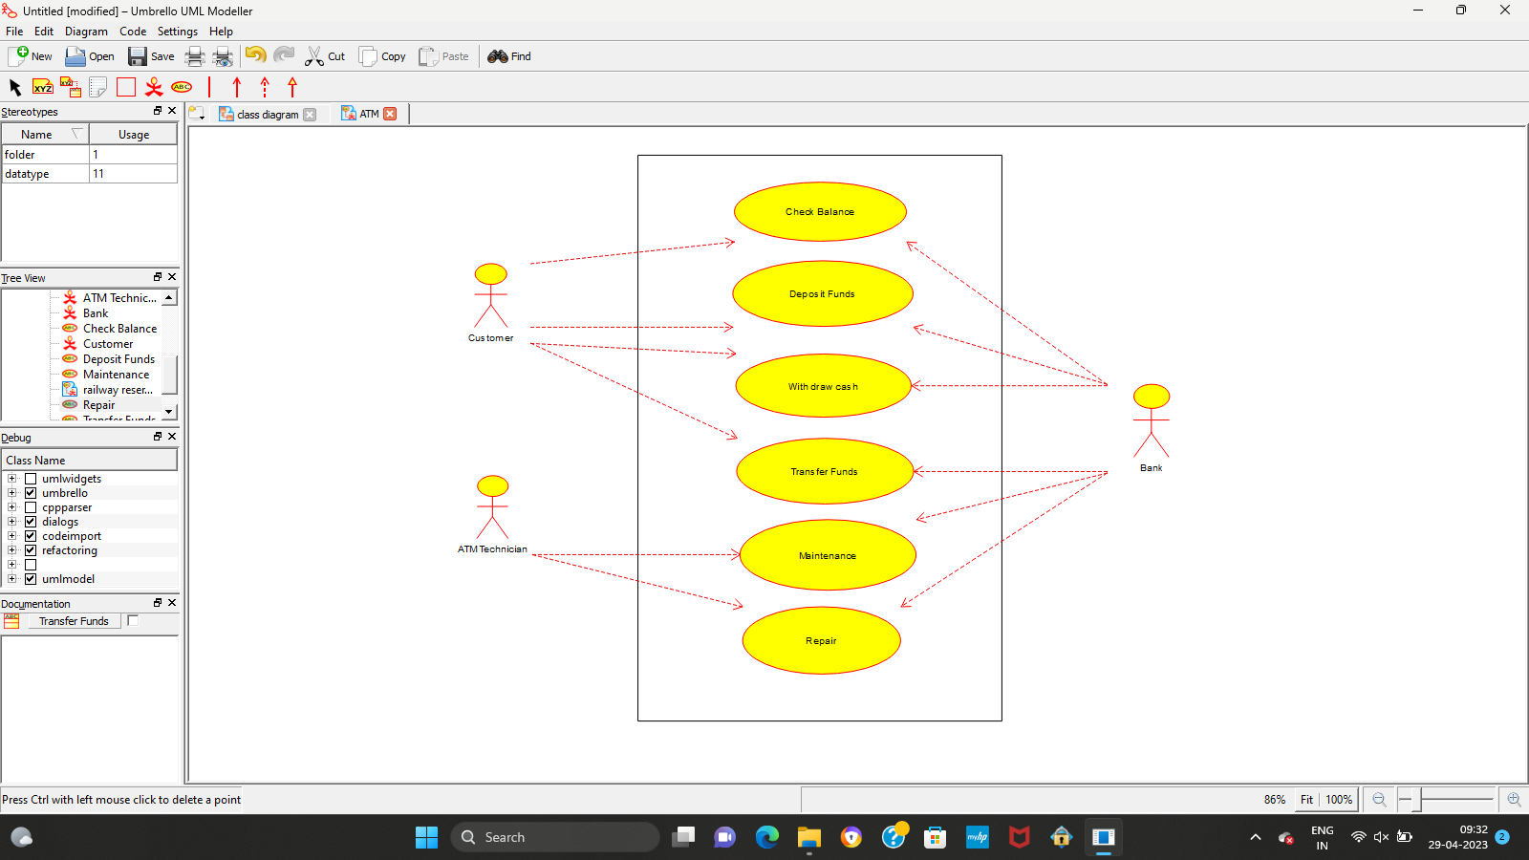

Result:-

Thus the use-case diagram for ATM is drawn and verified successfully